Below is the CNUT capture analysis:

1. We have noticed lot of "Inerror" counts

Ethernet Control Block Statistics
Ethernet Link Detected | 1
Ethernet Link Lost | 0
Undersized Toss Count | 0
inoctets Count | 2261952409
inucastpkts Count | 866151597
Innucastpkts Count | 1816879
indiscards Count | 0
inerrors Count | 299756

2. In the below Engineering Event log, it says "Acquired sync pulse" which ensure that the sync was lost and regained. “Radar detected” because of this we may have lost the link and it reestablished when the AP rebooted.

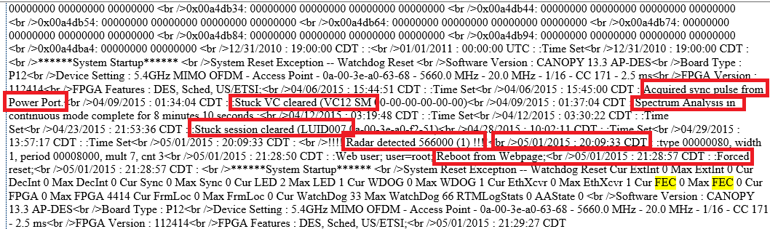

3. DFS alternate frequency was not configured. So, the AP could not switched to another frequency when the Radar detected. Hence, it stuck and reboot was required.

DFS Status

Current DFS Status
Primary RF Carrier Frequency | Active, 5660.0 MHz, Normal Transmit
Alternate RF Carrier Frequency 1 | No Frequency Selected
Alternate RF Carrier Frequency 2 | No Frequency Selected
DFS Detections | 0

