Guest Access Portal-Office 365 login Configuration

Guest Access Portal Office 365 Logins
- Introduction: -
This document described how to App ID and Secret for Office 365 login buttons in splash page of Guest Access Portal.
- Summary:
Office 365 logins, allows guests to log into the captive portal with their existing Microsoft outlook credentials . The page will include links to the office 365 you have enabled in Access method page. When the guest clicks on Office 365 , they will be redirected to that provider and asked for their office 365 credentials. Upon entering their credentials, approved the details we are requesting, they will be redirected back to the Login page.

This feature is supported from 1.5.1-r15 cnMaestro build.
Devices supported: E400/E500/E600/ePMP 1000 Hotspot.

- Precondition:
For office365 we internally add the first initial domains required for the Office365 login into the whitelist on the device which are "secure.aadcdn.microsoftonline-p.com" and "login.microsoftonline.com". You still need to add the domains on which your microsoft account is hosted. If it's on microsoft provided server then you will need to add "account.microsoft.com" into the whitelist. Under the office365 config on the cnMaestro guest portal you will find an option to add the whitelist entries. Once you add and hit save the new values are pushed to the device. If in the whole login process if you still get redirected to another domain then please add that too.

- Social Logins Configuration:
- Create ID and Secret for Office 365
- Configuring ID and Reply URL under Office 365 Guest Access Portal.

Procedure for Creating App Id and Secret

- Login to Office 365 developer console at https://apps.dev.microsoft.com with any of your Microsoft outlook account
- Click on “Add an AP” as shown

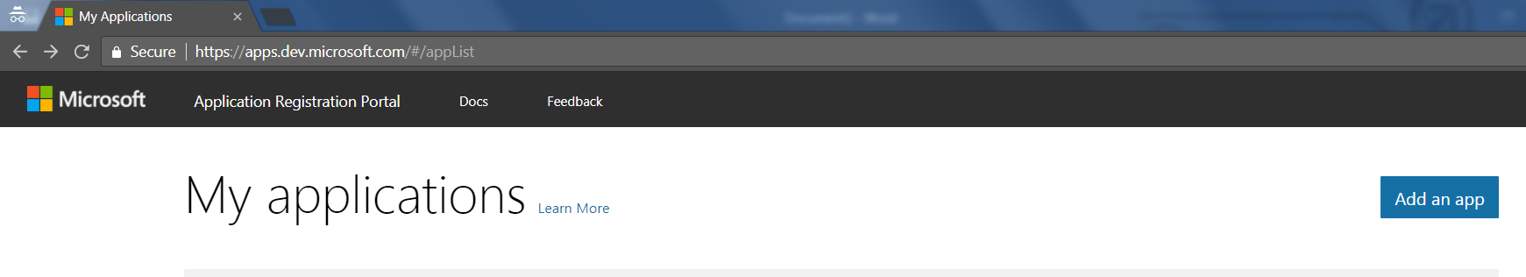

- Provide Application name and Contact email and click on Create as shown below

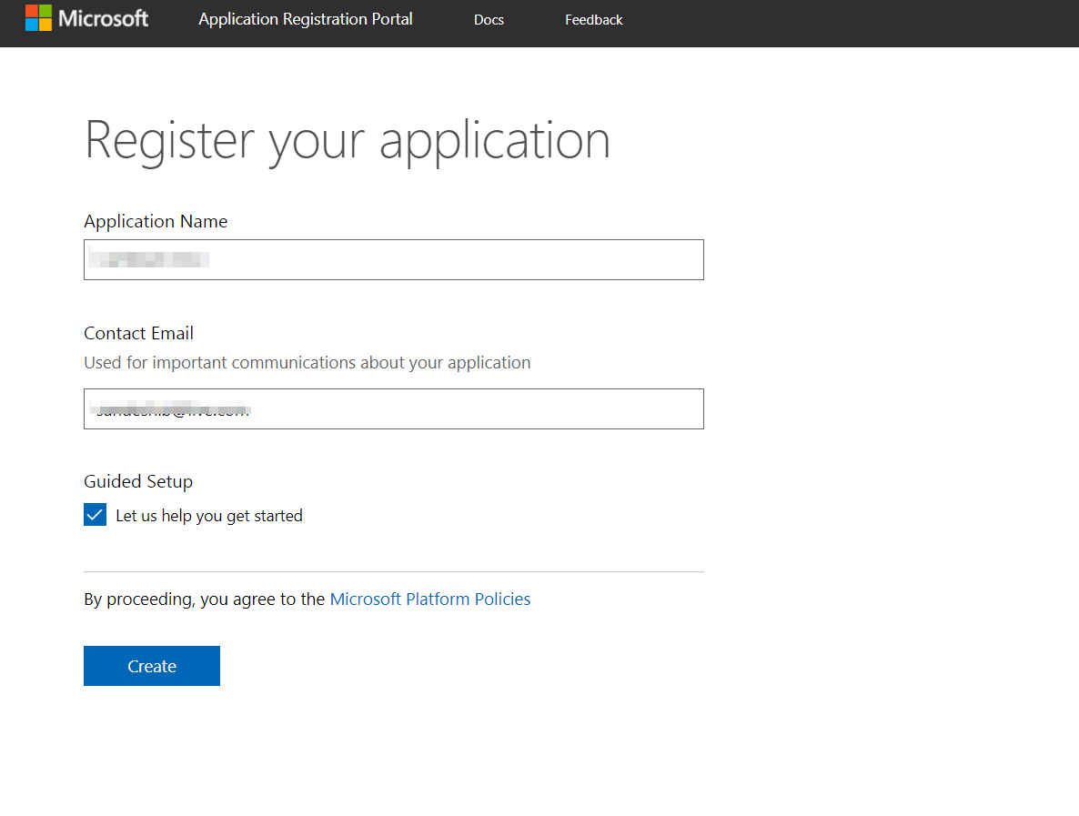
- Skip the Guided Set up
- You will be redirected to App registration Page where App Id will be automatically generated as shown below

- Later on the same page , you have Application Secrets .Click on Generate new Password as shown. Copy the generated password since it is displayed only while creating . This newly generated password is your new secret .
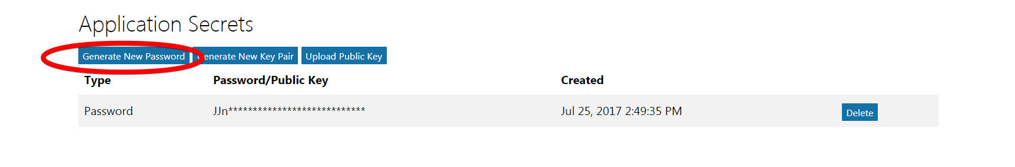
- Now on the same page ,Under the “Platform” section .Click on “Add Platform” and Select “Web” as shown below
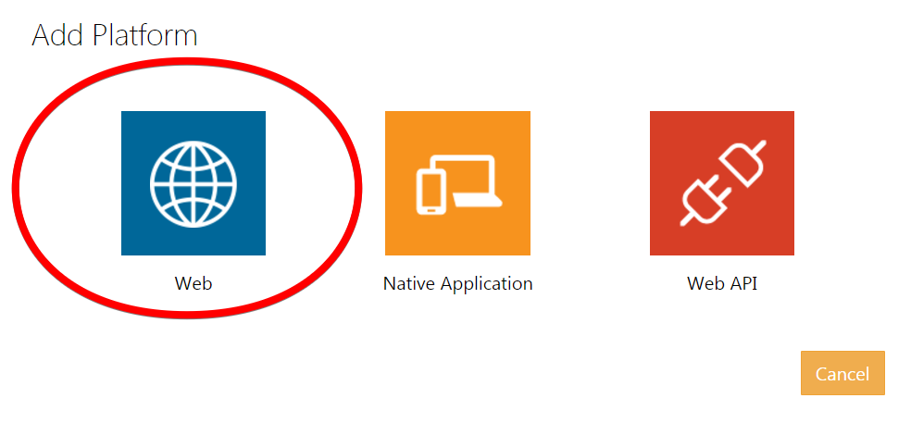

- Later You can de select Allow implicit flow based on your requirement . It is enabled by default . In Redirct URLs , Copy the Reply URL which is obtained from Cnmaestro Guest access portal Page as explained in Configuring Guest access Portal section Page

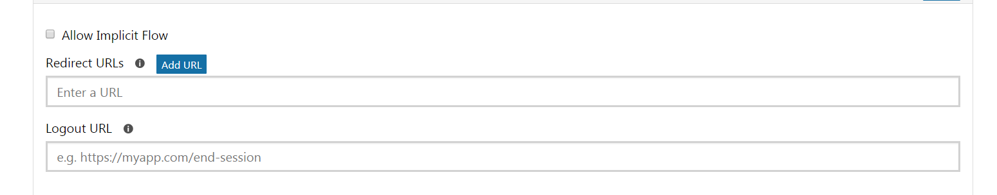
9 . Leave other Options as it is and Save

Configuring Office 365 in CnMaestro

  - Click on Guest Access Portal
  - Under Social Login section
  - Enable office 365
  - Now You will see Reply URL and Id as shown below
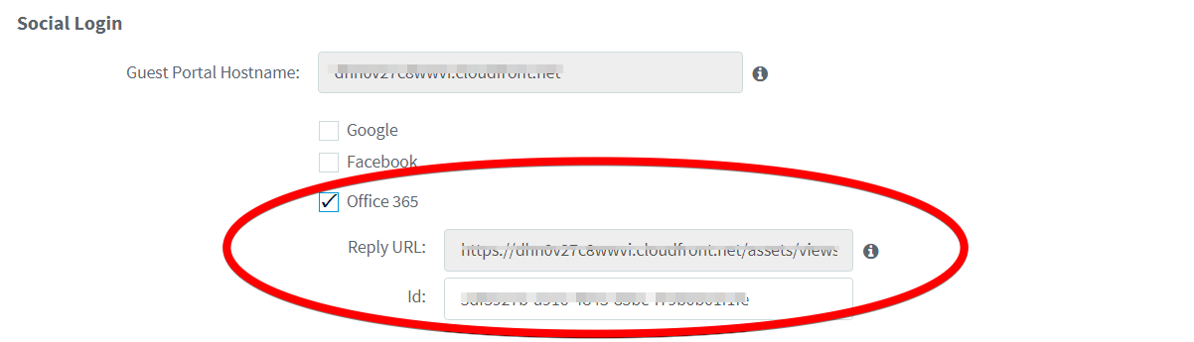
  - Copy the Reply URL from Here and Paste it in as shown in above section
  - Copy the App id created from above section and paste it here
  - Save Guest Access portal page and Splash Page
  - Splash Page will look like below once configured successfully
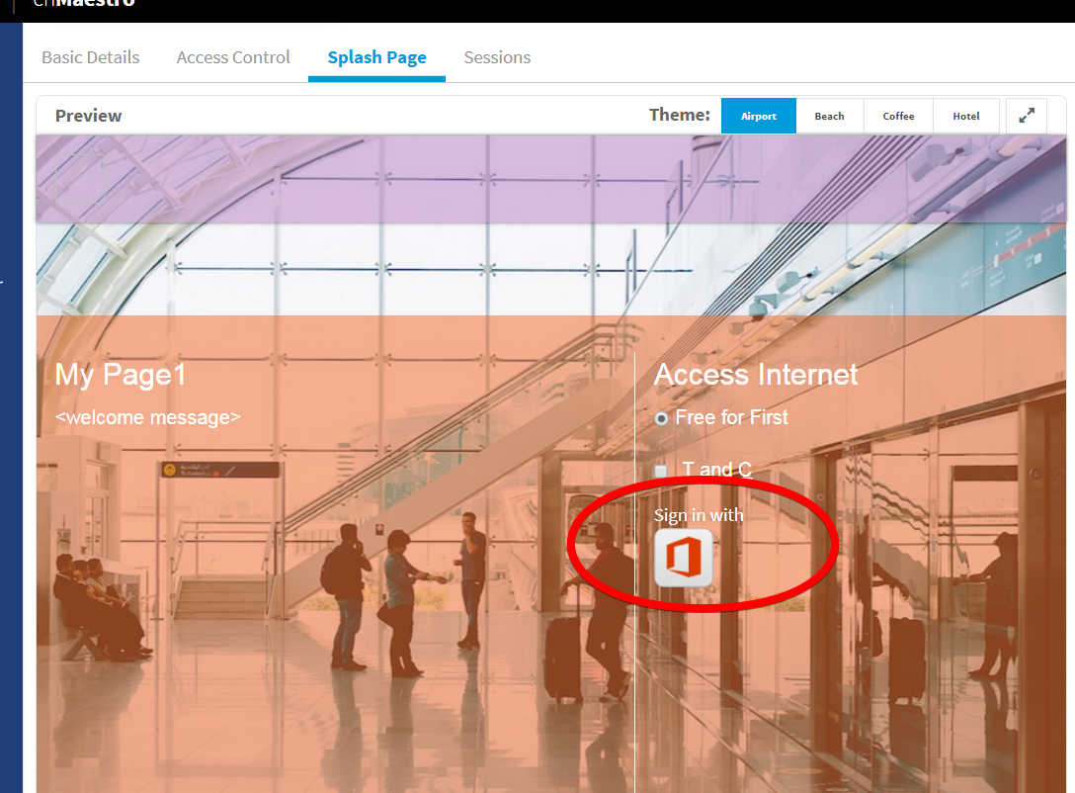

  - Now user can connect the Guest clients and login with Office 365 Microsoft Accounts

