Microsoft Office365 Social Login Guide

Version: 1.0

Table of Contents
Introduction 1
Microsoft Office365 Application Creation 1

Introduction
The Office365 business and school accounts are supported as a social login authentication method in the cnMaestro based guest portal. Admin can create a guest portal under services options in his cnMaestro account. Once a guest portal is created the user is presented with couple of tabs which provide options to configure the login methods for the given guest portal and the splash page customization. In the free option of the guest access one can find the various possible methods of the guest login. One of them is “Office365” and it requires the admin to configure the application ID which he must create in his office365 account. Along with the application ID one has to add the office365 business server into the whitelist so the guest client can perform the login on the office365 server. The below page also has the option to add required domains into the whitelist.

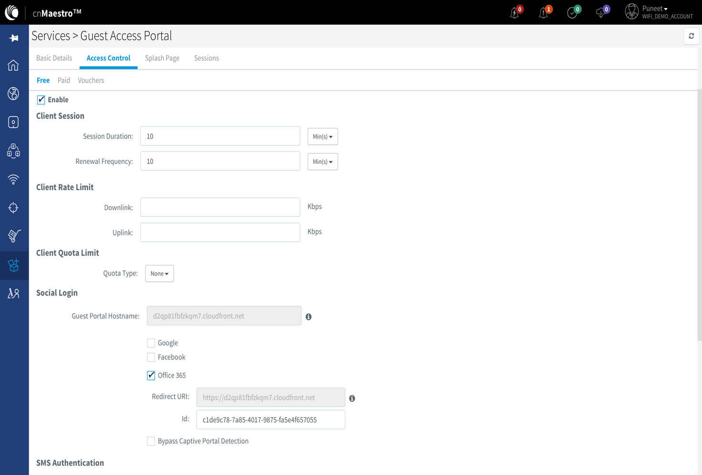

Microsoft Office365 Application Creation
Admin can login to its administrative account of his business or the school account and go into the ‘App registrations’ and create an app there. In the app settings one has to configured the reply URL same as the one shown in the cnMaestro configuration Redirect URI. The Office365 login application matches this value during the guest login process which is presented in the login splash page to the application. In case of a missing reply URL or misconfiguration the login will fail and error is shown in the Microsoft login page with the invalid replyURL.

Below steps show a new trail account creation for the office365 and the creation and required settings to be done on the application.

Please go to https://account.azure.com/ to start the procedure of account and application creation and setup of it

Step 1: Sign in process to account.azure.com
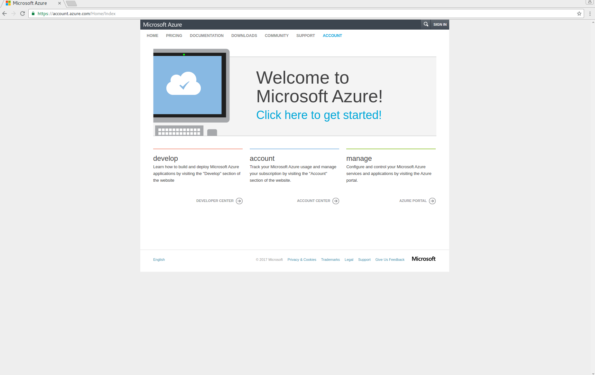

Step 2: Select Sign up for a free trail
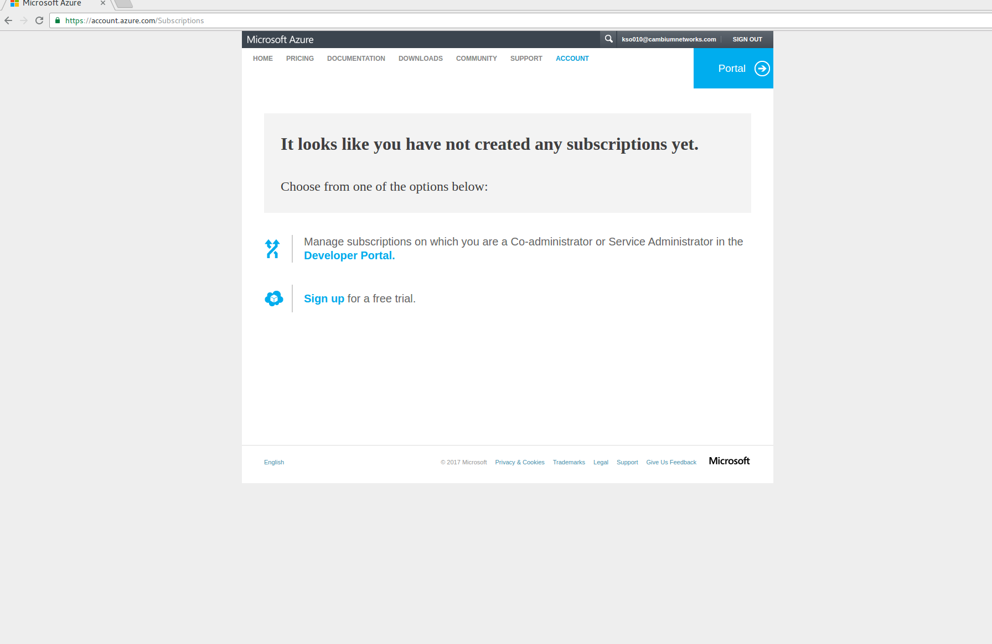

Step 3: Fill the form with details about your account
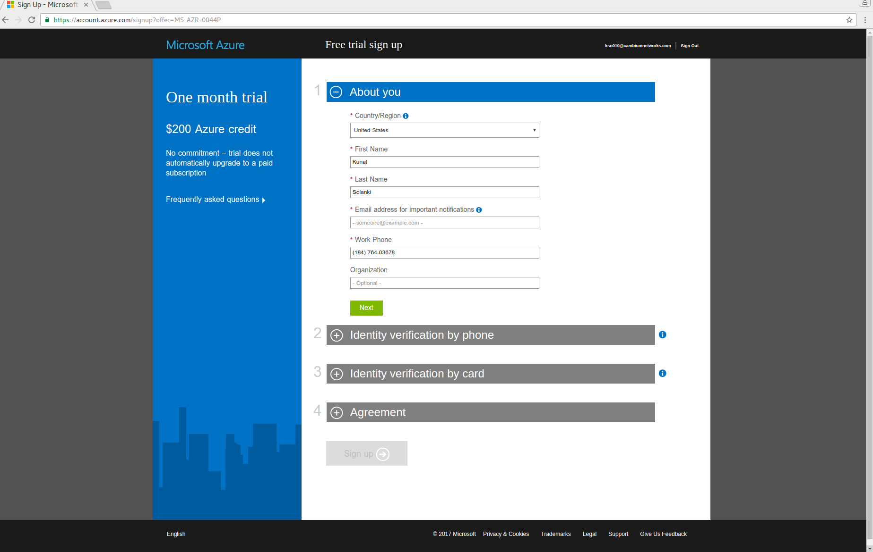

Step 4: Provide the phone number for OTP
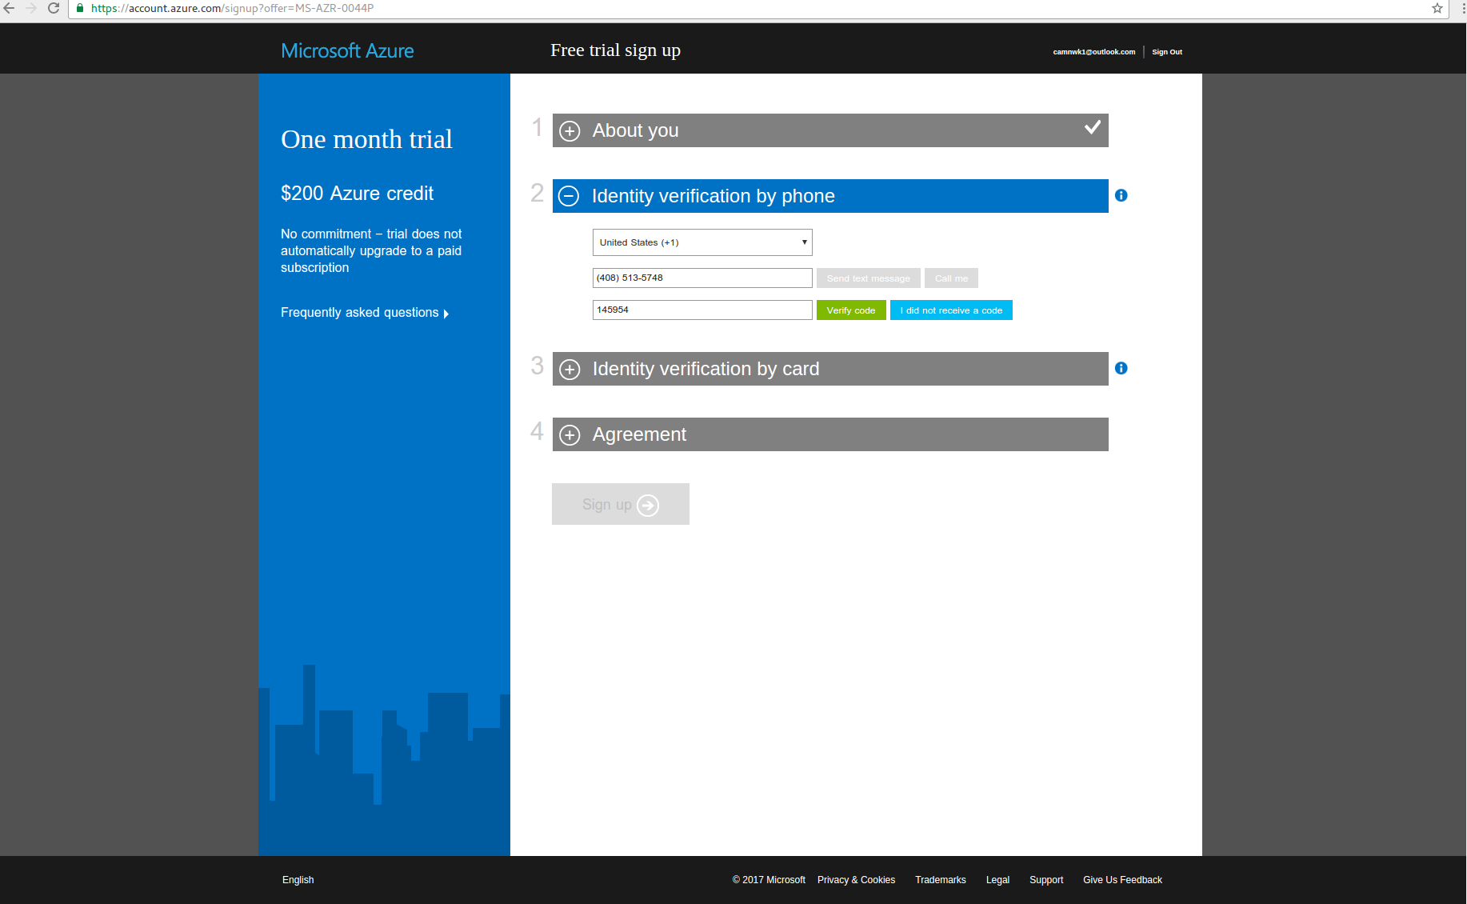

Step 5: Provide a valid credit card which is required by Office365 account
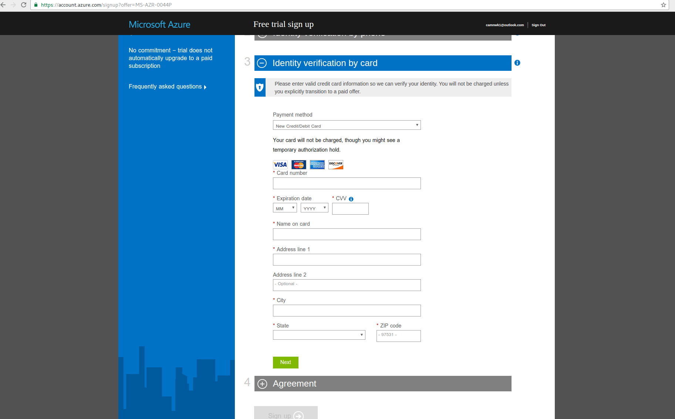

Step 6: Agree to the Agreement and complete the Sign up process
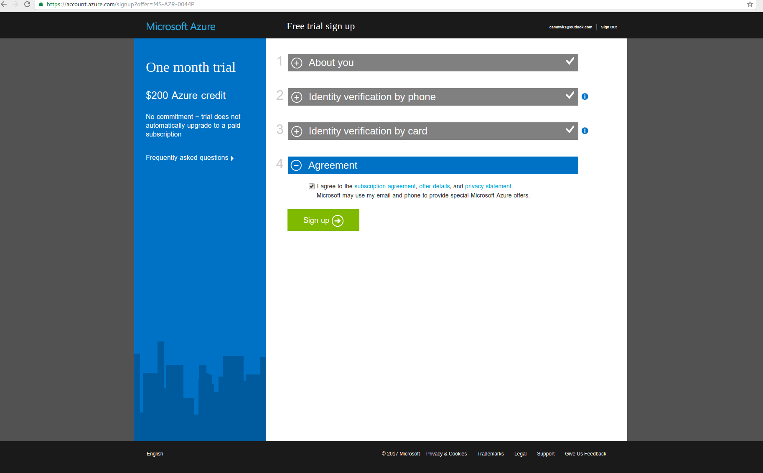

Step 7: Click on the “Get started with your Azure subscription”
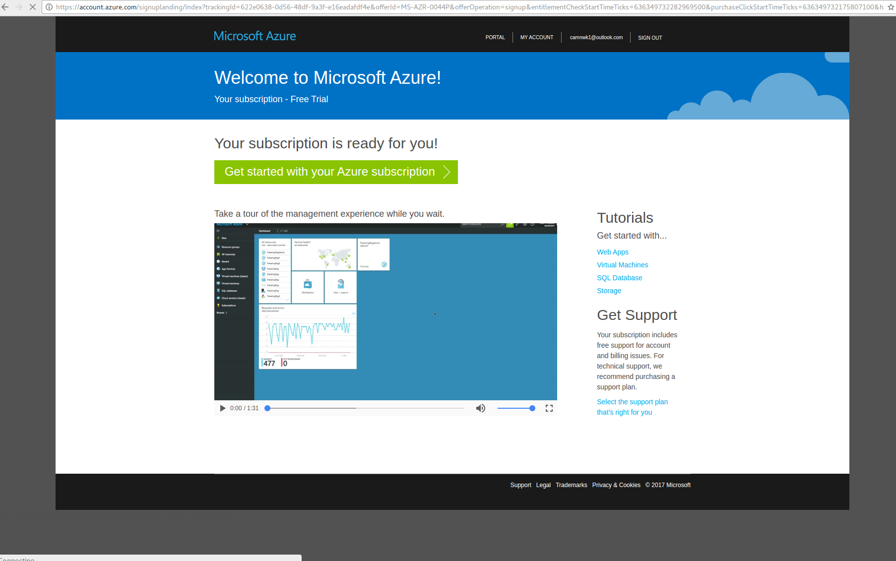

Step 8: Once on “Dashboard” click on “More services” at the left most bottom corner of the page
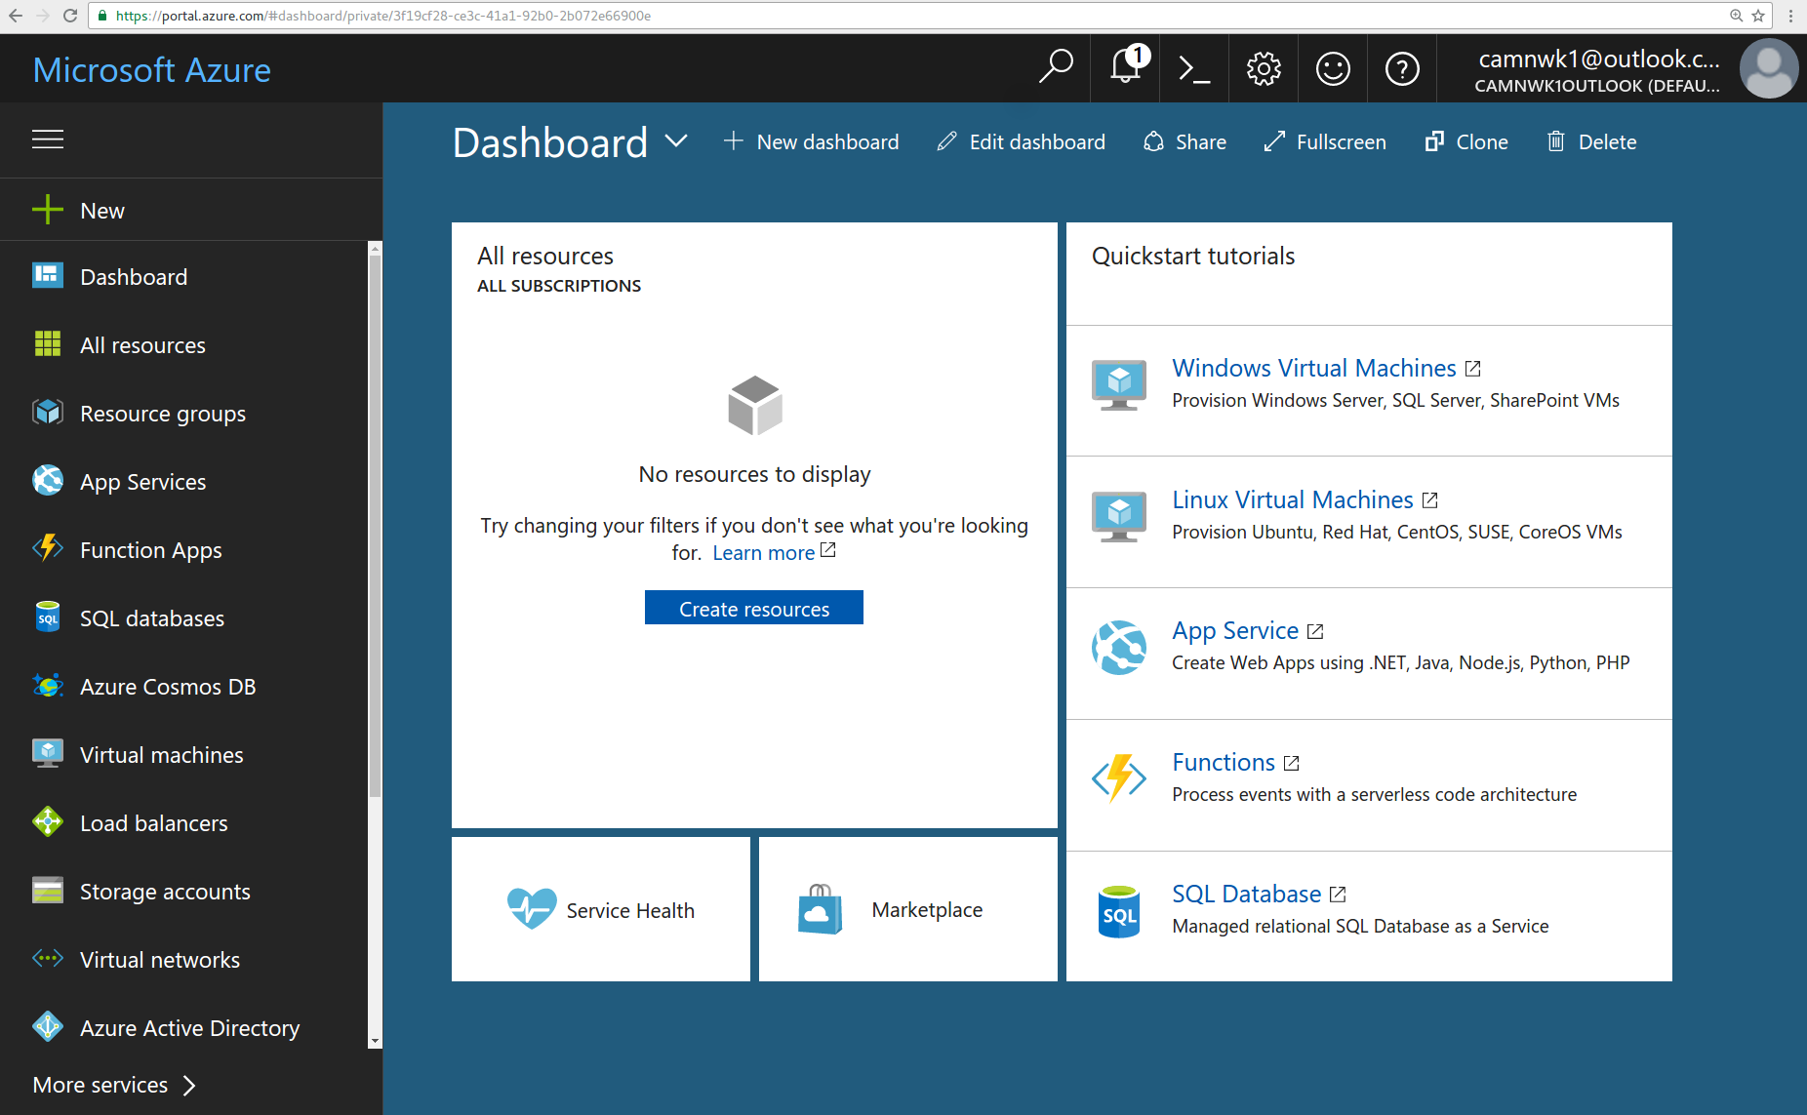

Step 9: Scroll through or search for “App registration”
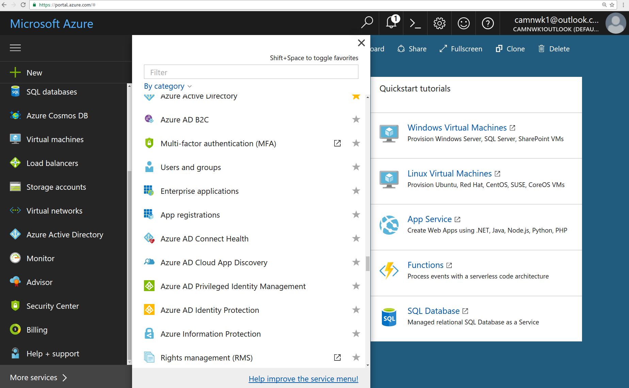

Step 10: Select “App registration”
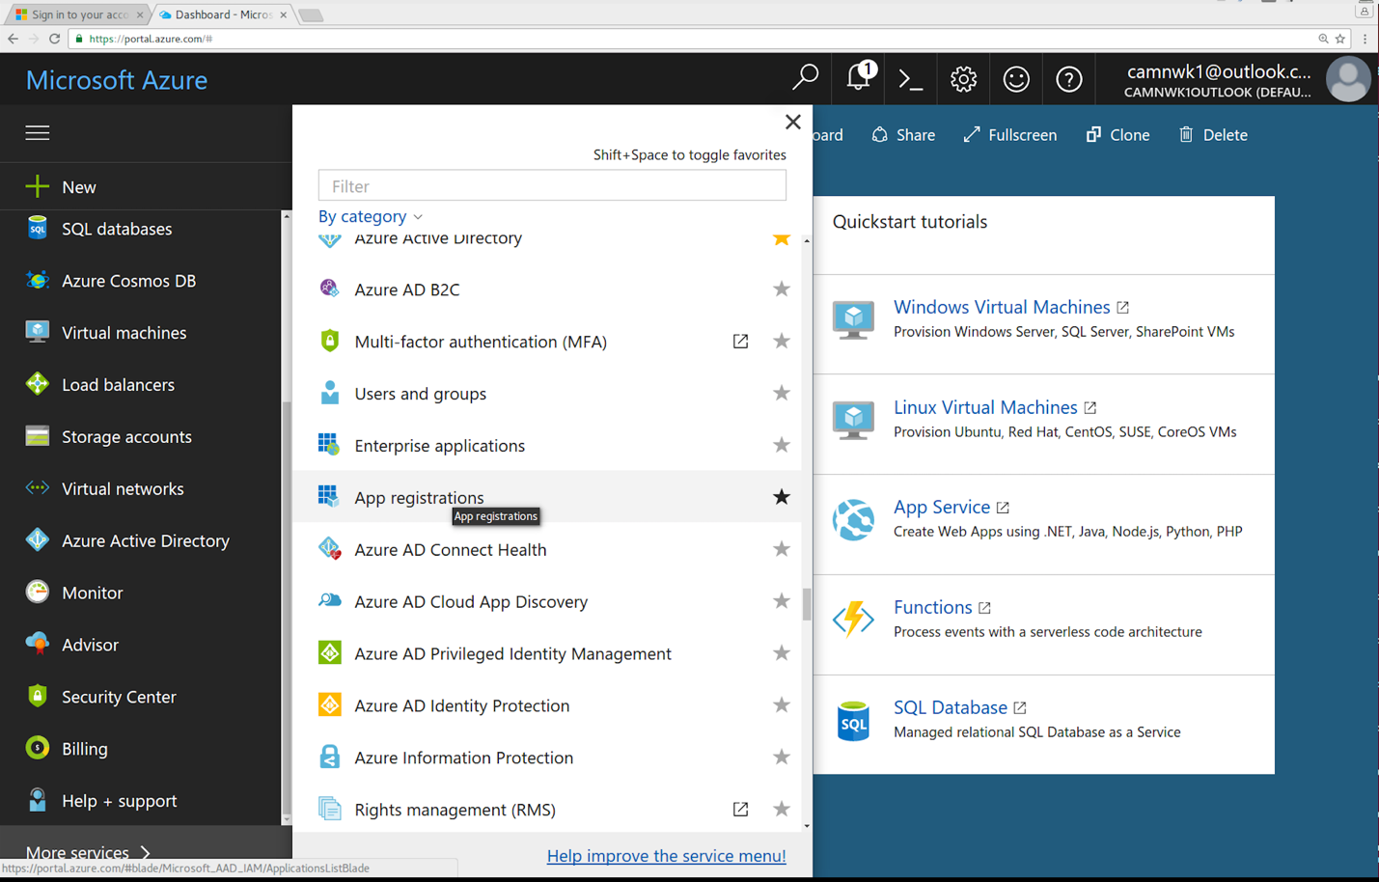

Step 11: Click on “New application registration”
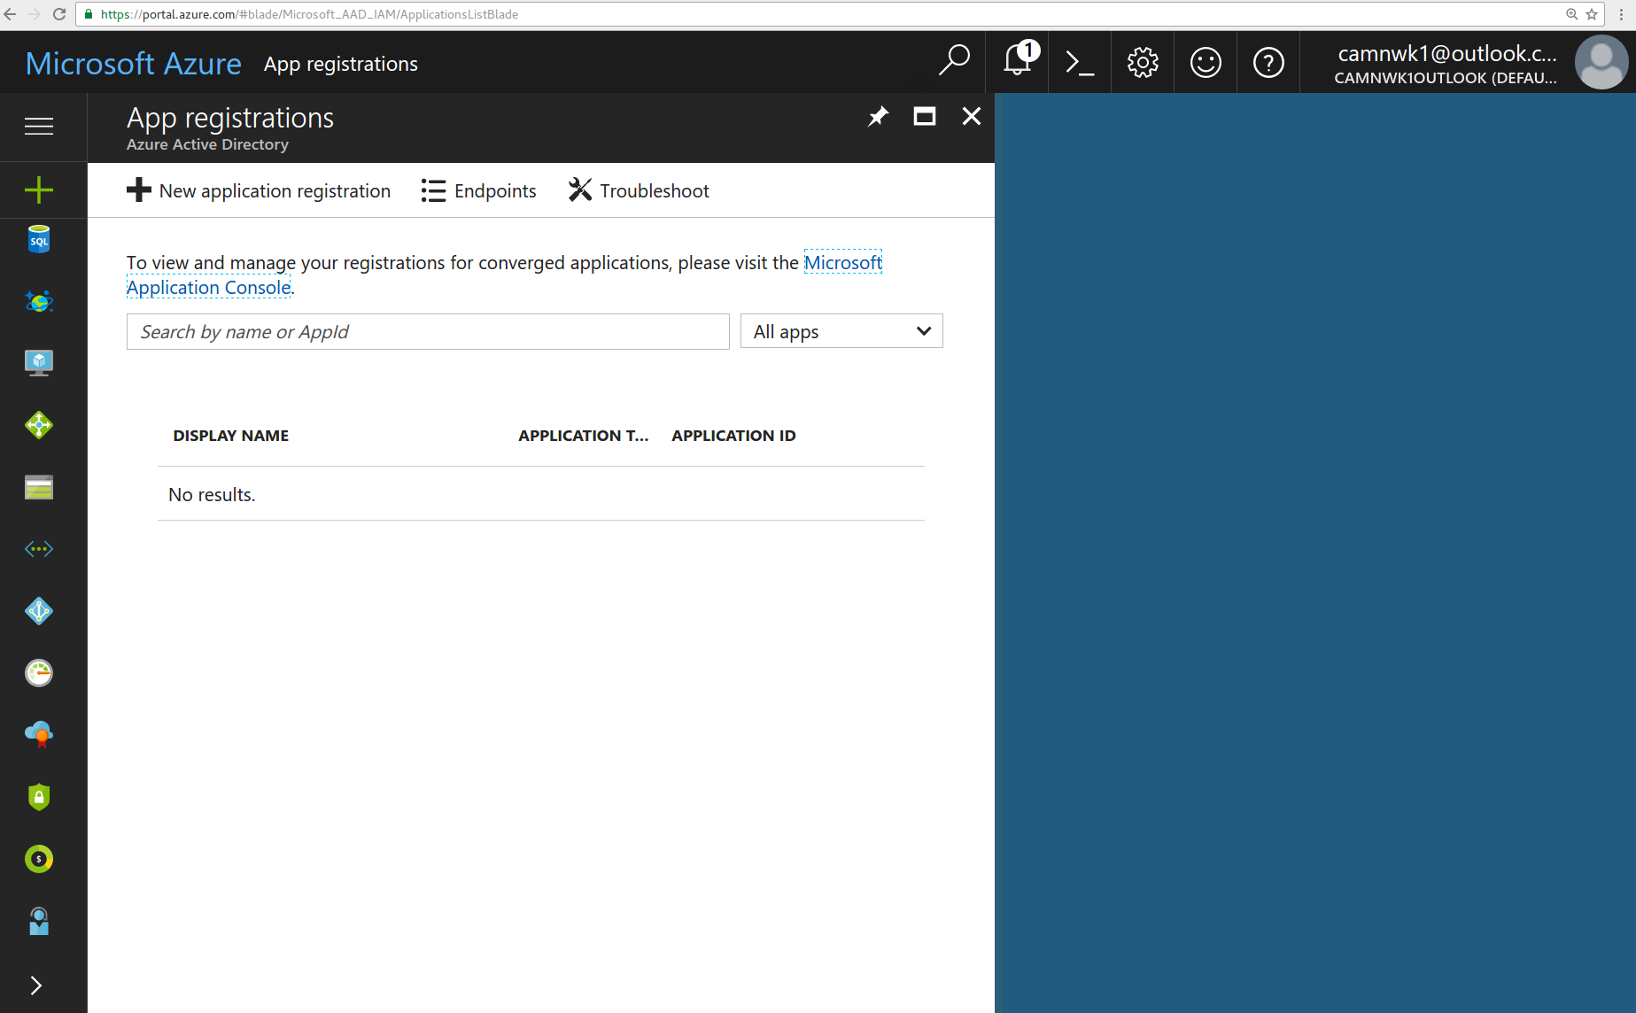

Step 12: Provide application name and the splash page URL, the splash page URL can be configured as the Reply URL value from the cnMaestro guest porta configuration. Also select the Application type as “Web app/API”.
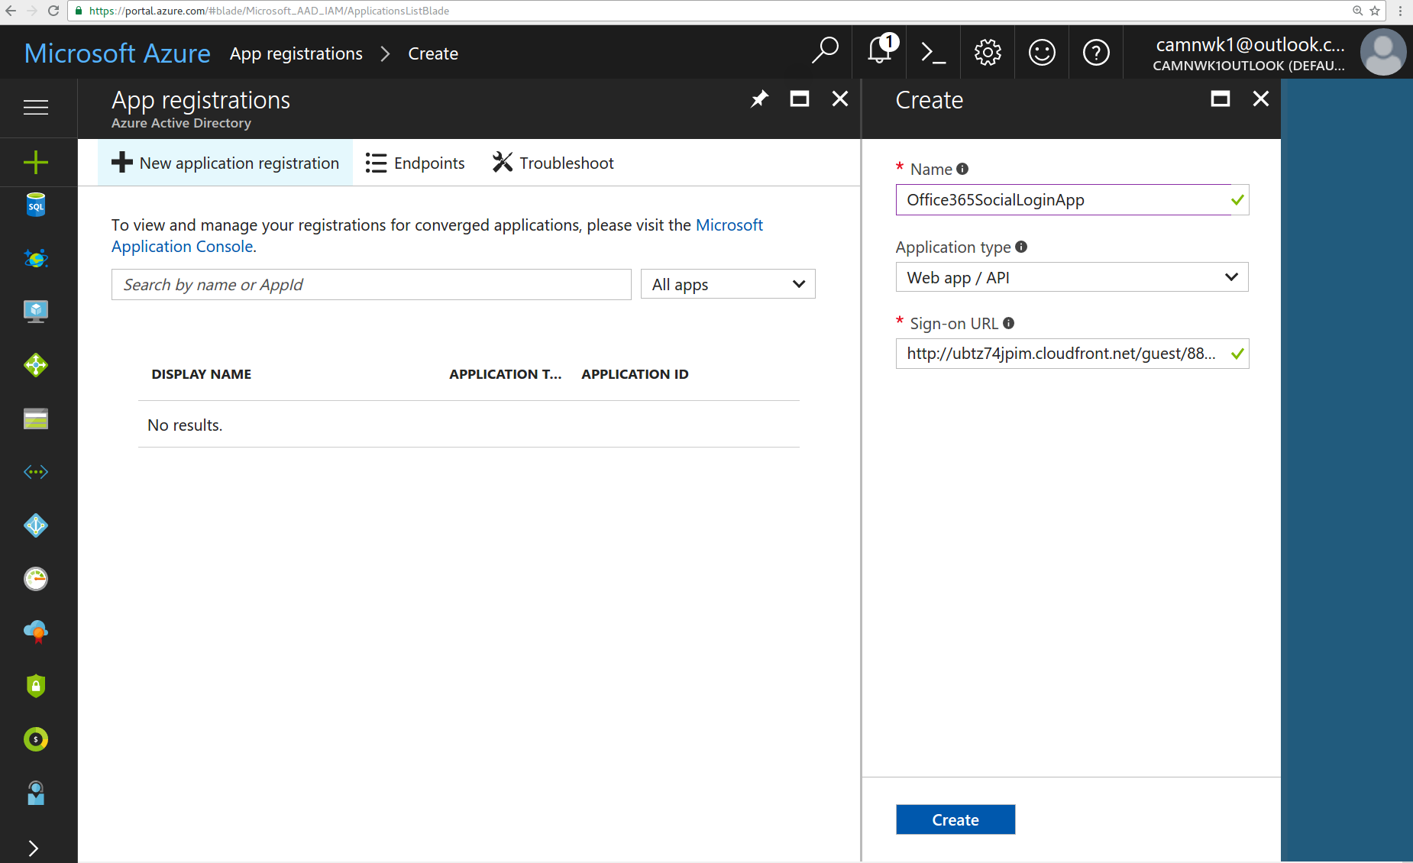

Step 13: Once application is created select it and you will move to Step 14 page.
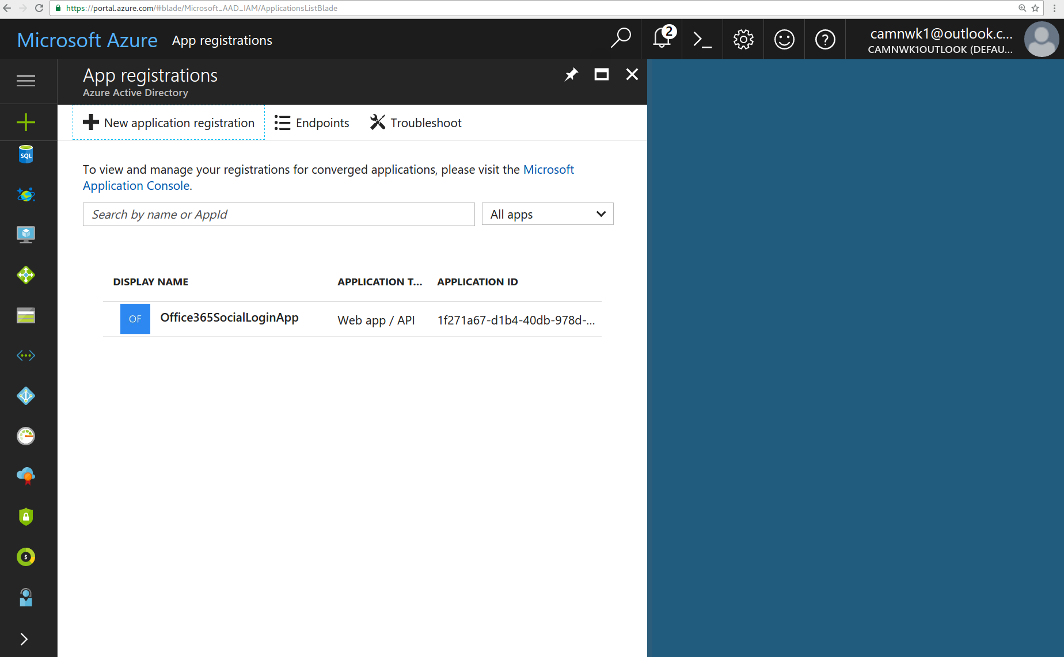

Step 14: Click on the “Properties” tab on the right
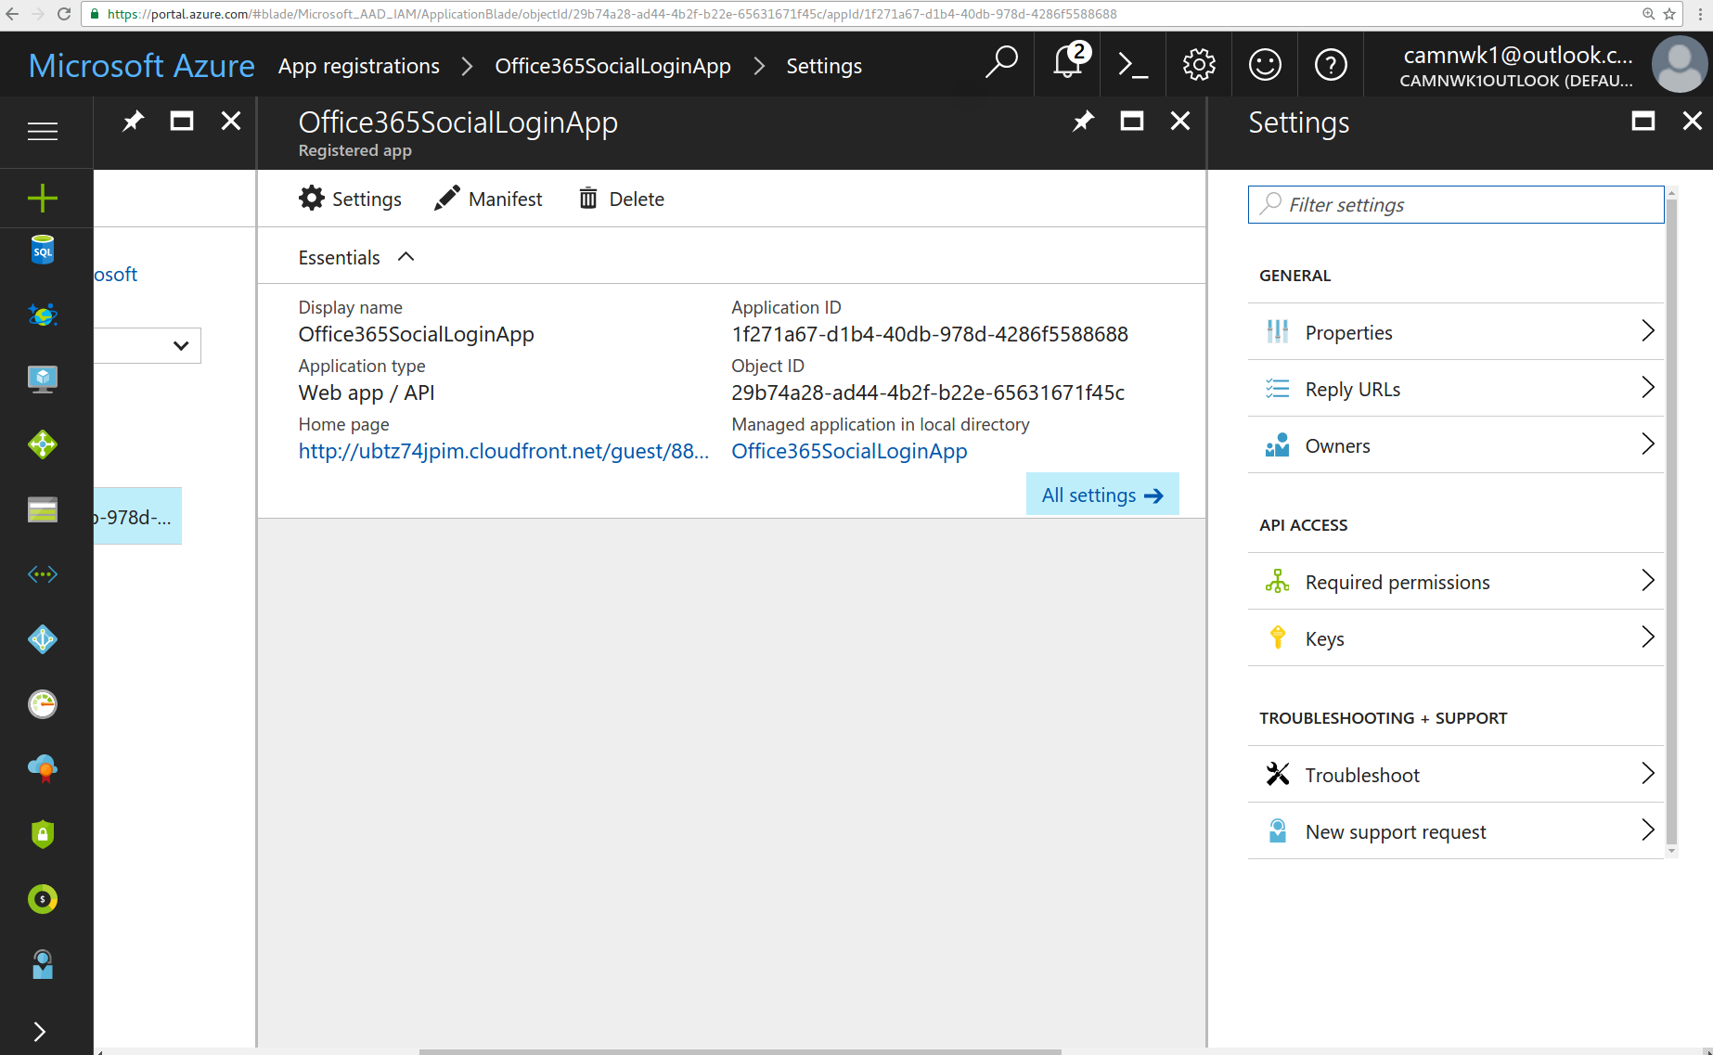

Step 15: If this is a trail account and you wish to allow sign in from other business/school office365 accounts then enable “Multi-tenanted”. If this application on a paid business account and you plan to allow sign in for only that business account only then leave this to default as disabled.
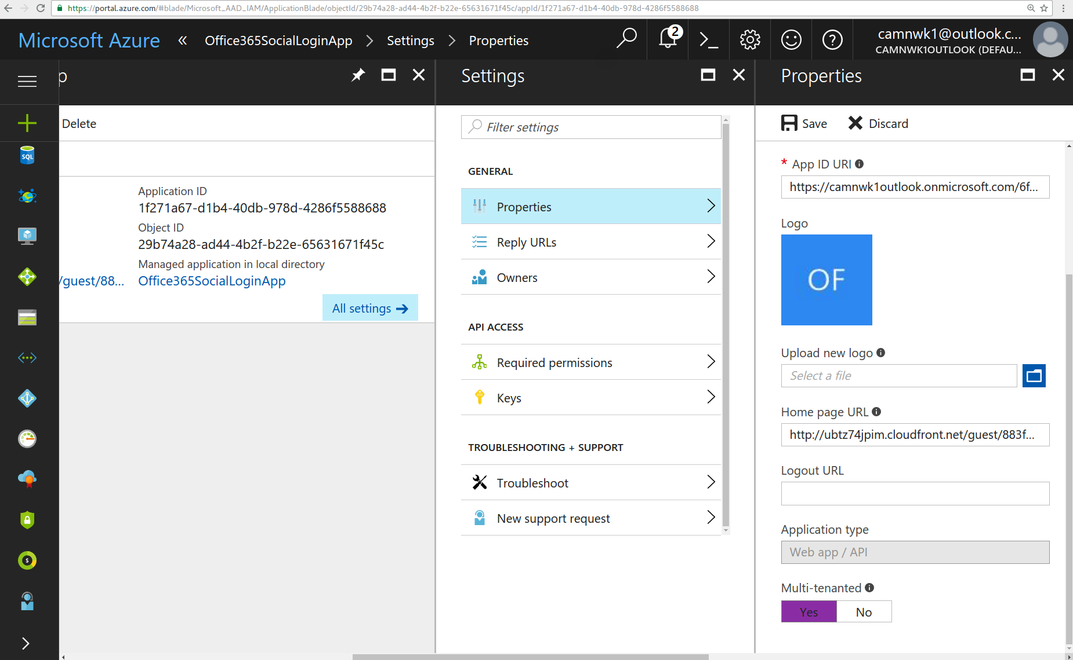

Step 16: Click on “Reply URLs” and configure the “Reply URL” from the cnMaestro guest portal account which is shown above the office365 app ID input box.
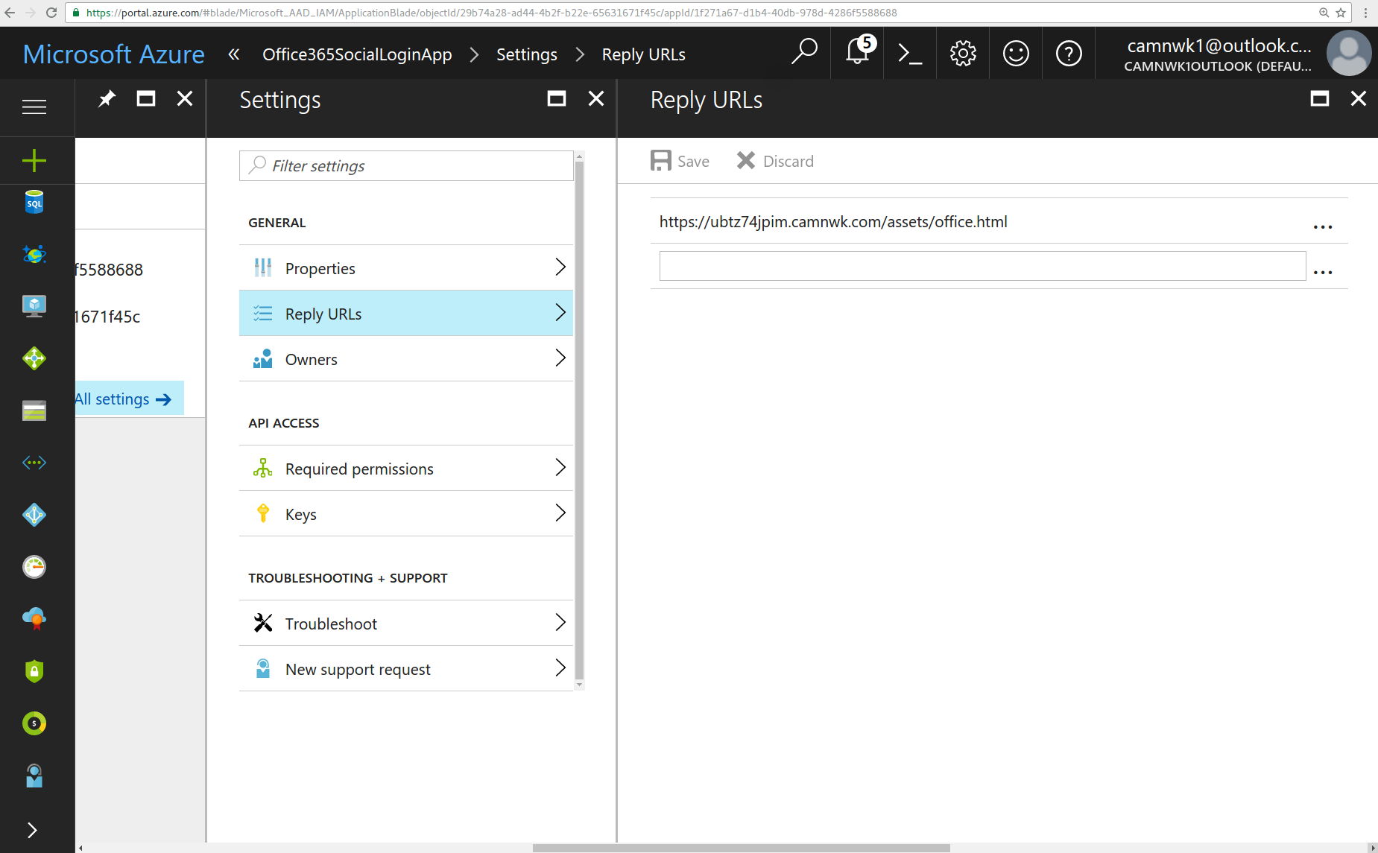

You are now setup with the account and should be able to perform login from the cnMaestro guest portal.

