RF Wi-Fi Planner
FOR
VietWorld

Drafted by: Phu Kim
Organization:
Date: 05-Oct-2017

DISCLAIMER
The elements presented in this proposal are predictive only. Cisco recommends that customers always perform an RF Site Survey before deploying a Wireless LAN network. An RF Site Survey involves temporarily setting up APs at the site, taking measurements to determine the RF environment, the best position for each AP, the coverage to be provided by each AP, assessing the overlap between the coverage areas and identifying and compensating for RF interferences. An RF Site Survey is also able to more accurately account for common real-world challenges: interferences that cannot be mitigated, areas of the site that cannot be covered adequately using standard deployment techniques, etc. As a result, an RF site survey is able to provide a more accurate representation of the number of APs required for a particular site, the areas of coverage, specific locations where APs need to be placed, the deployment types (AP power, antenna type and orientation, etc.) and the effective throughput of the wireless LAN network based on the wireless client types and expected density.

Table of Contents
1. Introduction 4
2. Customer Requirement 5
3. AP Placements 6
4. Bill of Materials (BoM) 11
5. Product Information 13

1. Introduction
Determining AP placement for data coverage, VoWLAN (or other real time applications) and location service scan be achieved through a professional site survey, a RF prediction tool or a combination of both. The Predictive RF Planner was carefully designed to allow you to predict the number and placement of access points without requiring an onsite site survey. The Predictive RF Planner automatically determines the number of APs required, their approximate location and the overlap between cells for a wide range of AP models. The underlying engine integrates each AP model radiation pattern, coverage area and client capacity at various power levels and for each frequency band. The Predictive RF Planner engine is based on measured data from a large quantity of existing wireless deployments and may be adequate for many deployments in typical environments. This approach is based on most enterprise buildings having common RF characteristics, and that only a part of the building needs to be characterized to verify the access point coverage for the entire building. This approach leverages the algorithms built into the Cisco WLAN Solution Radio Resource Management (RRM) that ensure that the overlap between access points is minimized and that coverage holes are detected and eliminated in most areas.
When deploying 802.11 wireless LANs to support critical applications with low latency tolerance, or in atypical environments, a few special considerations are needed in the design and deployment process, and an additional onsite site survey is recommended. However, the Predictive RF Planner is an ideal step to perform the initial evaluation of the number and position of access points that may be needed. In standard environments, Predictive RF Planner is likely to provide enough information to proceed to deployment without requiring an extensive onsite site survey.

2. Customer Requirement
The following proposal was generated by Predictive RF Planner, based on the information imported into the tool.
Customer Name: VietWorld
Address: B?n Tre,B?n Tre,Vietnam

Building Details:
Building Area: 6,612.49 sq. meter
Number of floors: 1

3. AP Placements
AP placement is a critical result of using the tool. Predictive RF Planner takes into account the expected usage of the network (data, voice or other real time application, location), the size and characteristics of the area to cover (including walls and other obstacles), to provide the best estimate of required AP number and position. Based on information about the environment that was not imported into the tool, you have the possibility to make manual adjustments in the number and position of APs. Predictive RF Planner also takes into account the general characteristics of the planned deployment to suggest the AP type that would best suit the customer needs.
AP placements are made based on the below selected parameters in the Predictive RF Planner tool.
Floor Details:
Floor Name | Floor 1
Coverage Area | 6,612.49 square meter
Floor Height | 9.0 meter
Band | 2.4 GHz
# of Users | 329
# of Devices | 543
Application Type | Voice : -67 dBm
Total # of APs placed | 11

AP Information : Floor 1
AP Name | AP1850
Quantity | 11
Antenna | ANT 2524DW
Power level | Power Level 3
Protocol | 802.11n
Channel Bandwidth | 20MHz
Spatial streams | 1

Predictive RF Design:
1. RSSI: -65 dBm
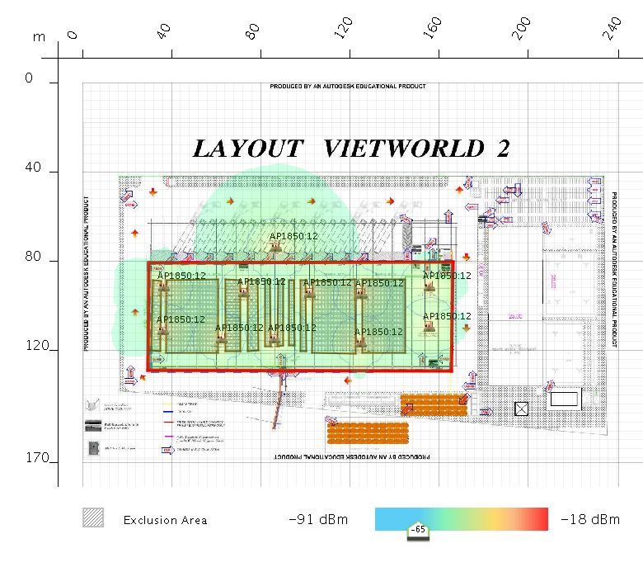
2. SNR: 28 dB
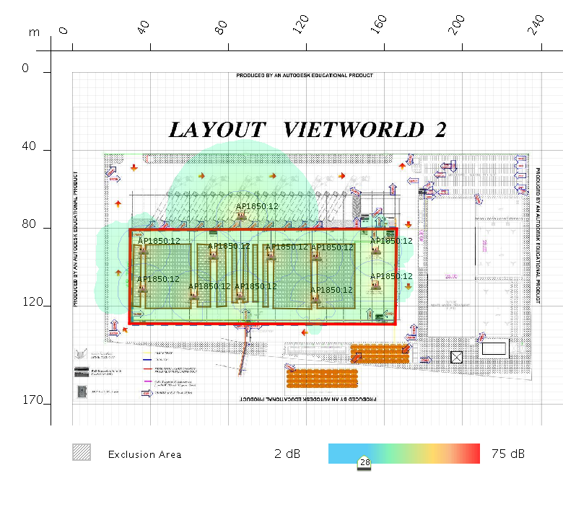
3. DATARATE: 2 Mbps
