Let’s assume you have deployment as shown in below image.
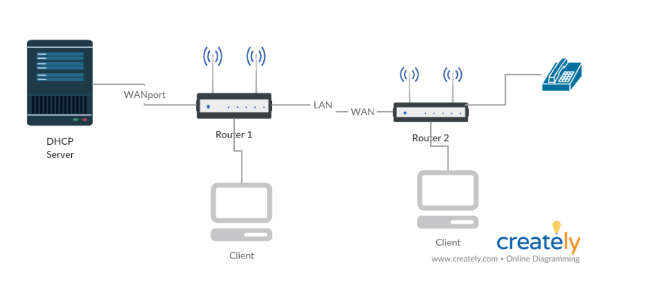
On Router 1, you will need to create 3 WAN ports.
- INTERNET in Bridge Mode.
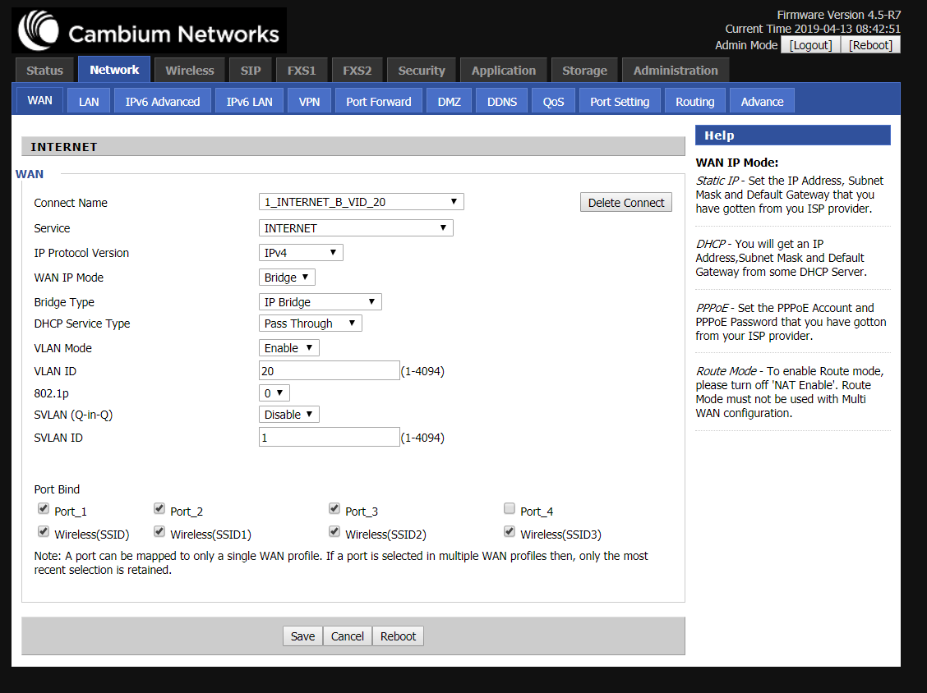

- Management Voice in DHCP mode.
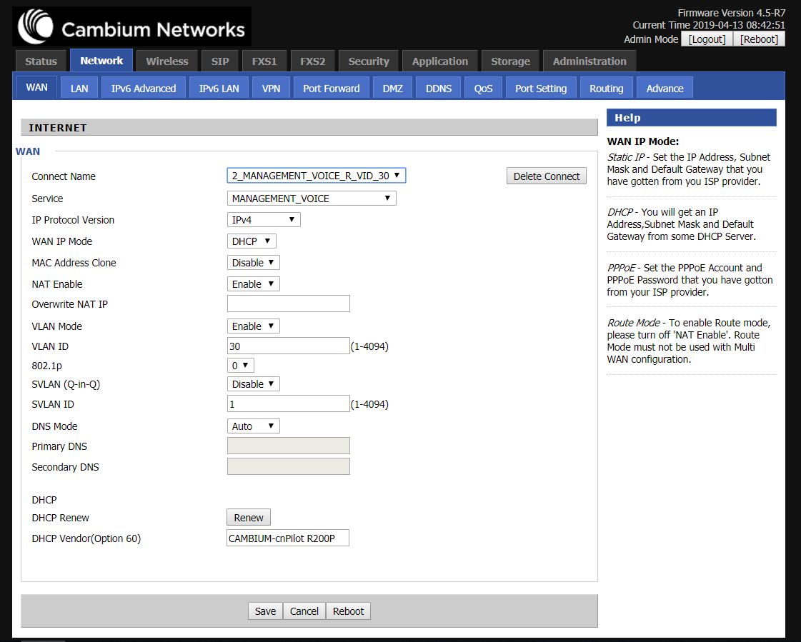

- Other in BRIDGE-Trunk mode (From this VALN 2nd router management and Voice will get IP in same VLAN). Don’t bind any port to it.
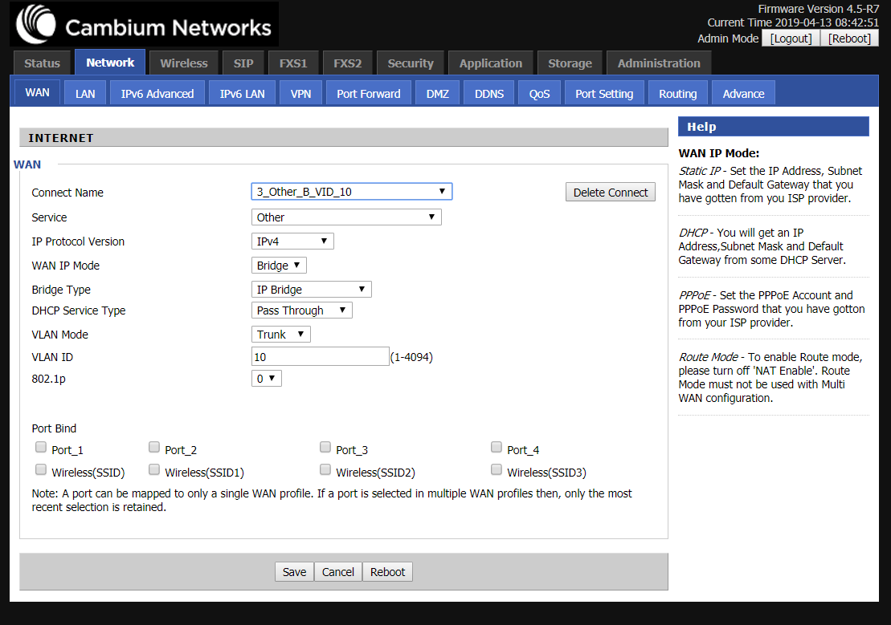

On Router 2, you will need to create 2 WAN port.
- Internet in VLAN disabled DHCP mode.
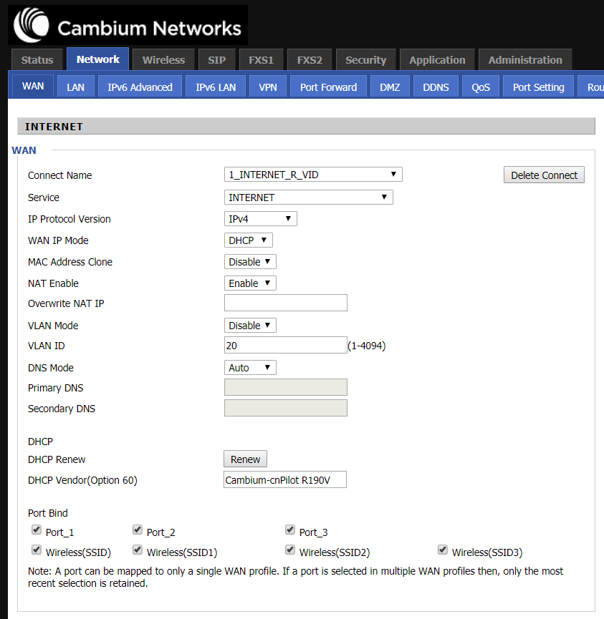

- Management and voice in VLAN10 (Same VALN as Other-bridge-trunk in Router 1).
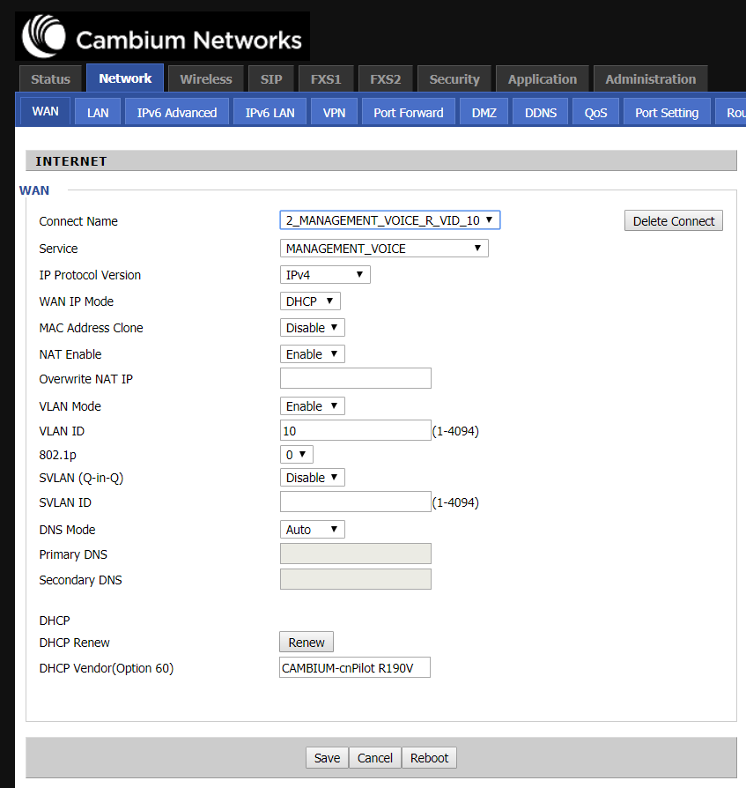
Limitation:
RBN-720: Cannot access device UI in https mode when client has got IP from Interface Other in trunk-VLAN.
You will need to configure 2nd Router in http mode and will be able to access only through http .
