**PMP100 Upgrade**

Please follow these steps in order to add your network to be updated.

Make sure that you have all the required packages.

Please check the platform of your units. Open CNUT application.

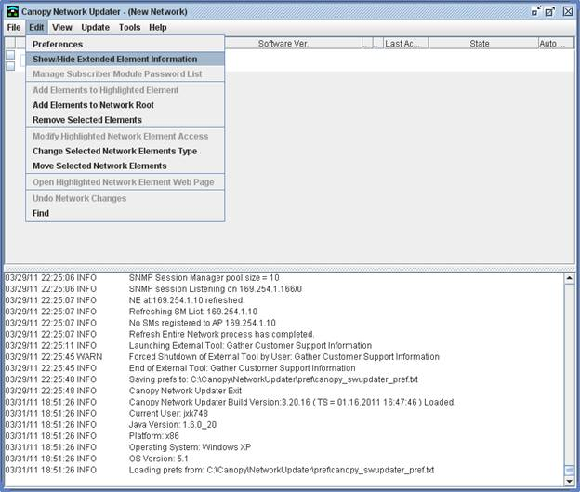         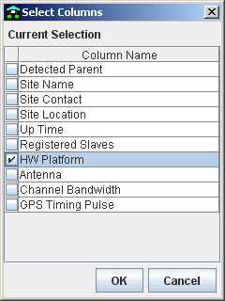           cid:image028.png@01CD11F7.D02D33B0

It should be higher that P8 or P9 if we want to upgrade them till the latest version.

Do Right click on network elements folder and choose *Add Network Element*.

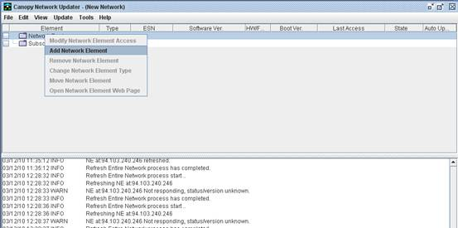

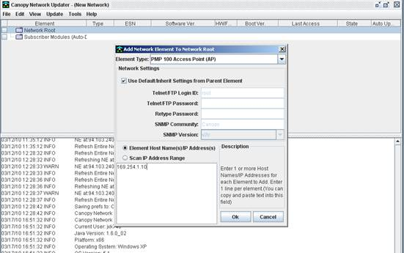

Please take a time to have a look at these fields.

* Big white box on bottom of window, where you put IP of element.
* Telnet/FTP login ID which must be root and same as root pwd on element
* SNMP Community : must be same in CNUT and element under SNMP settings

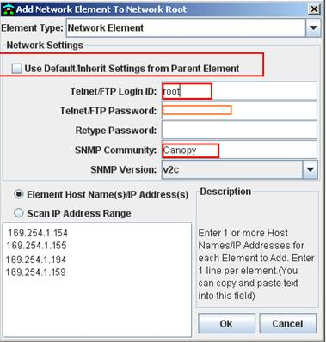

By default you can see all fields marked here, (*gray*). Once you uncheck the box you will be able to edit these fields.

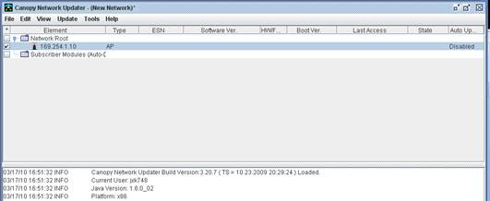

Now you are able to see the element and you need to refresh it to see if your password match.

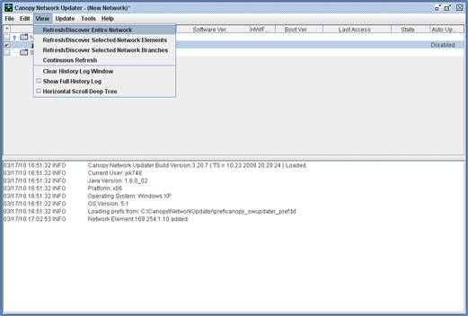

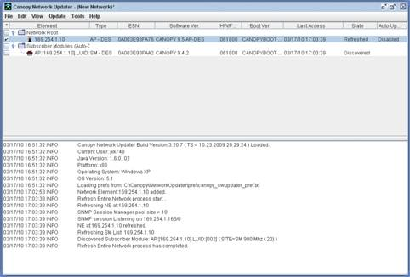

So now you see element up and refreshed. But the ROOT pwd must be same in CNUT and ELEMENT.

The SM was discovered under Subscriber modules.  If you want to upgrade them you need to move them under your network root.

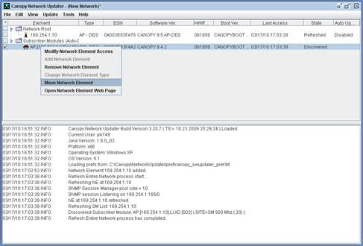

Right click on element and select move .

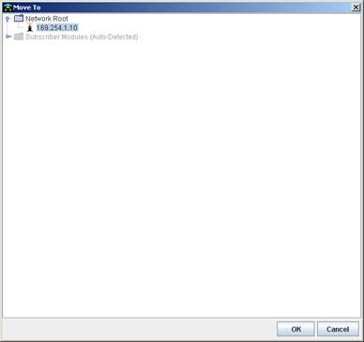

Choose that AP which this SM belongs to.

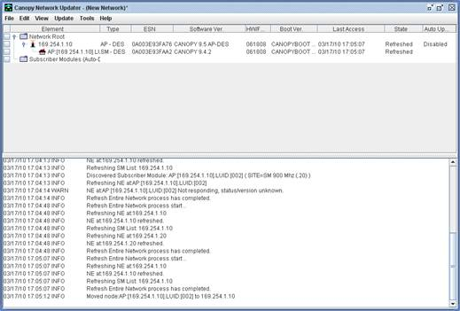

And here you can see it. You need to change IP of this element. Press double click on it and change it IP.

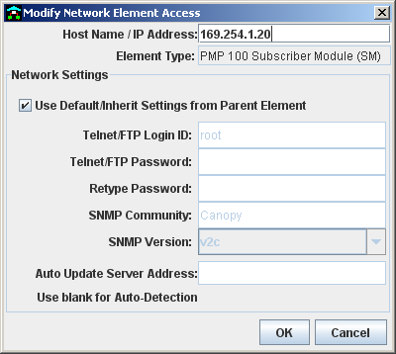

Here you can see where. This IP must be reachable from your PC.

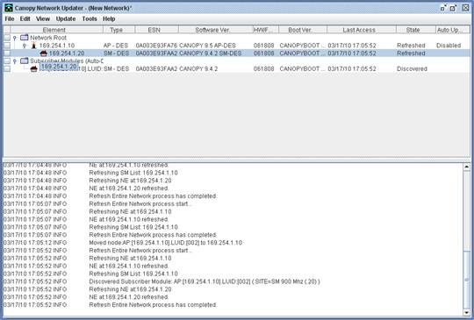

Once you change IP please refresh network to be sure you can see.

Please try to go till the last version 11.2 in all units.

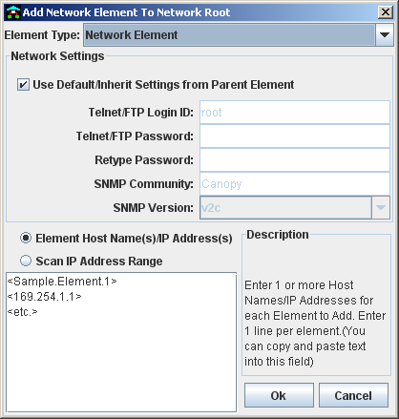

SNMP Community, device Password

Refresh the network.

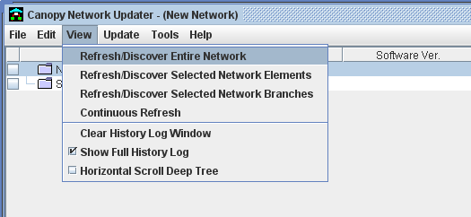

Select all networks,  go to select the packages

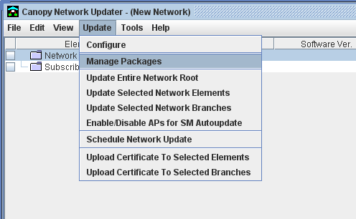

Select the preview package, if you are going to the latest version, the first one….and one by one

7.3.6 -> 8.2.7 –> 9.0 –> 9.4.2 –> 9.5 –> 10.3.2 –> 10.4 –> 10.5 –> 11.2…

Select’ update selected networks’

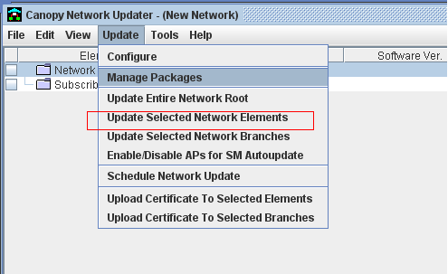

***IMPORTANT NOTE ;***Before going to de version 7.3.6 you must change the advantage Platform Scheduler.

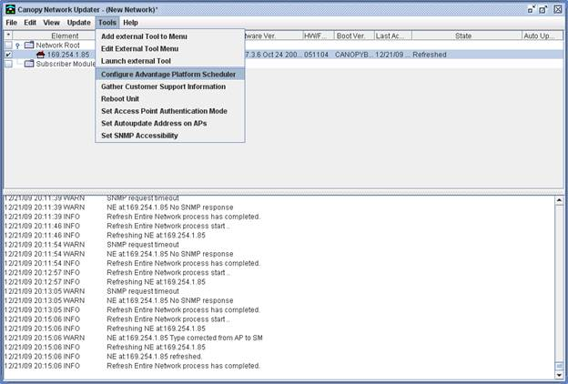

After we see our unit refreshed , go for Tools → Configure Advantage Platform Scheduler. The window will pop up as seen bellow:

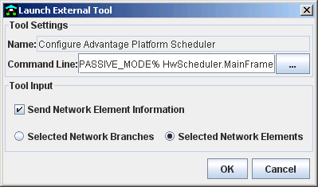

 Follow settings on this screen.

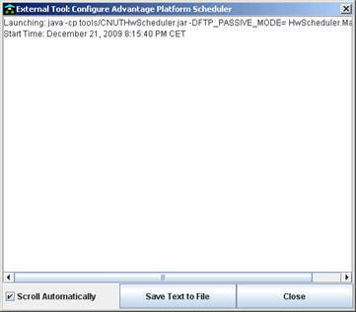

This window will appear, and it will inform you about all processes which are done by CNUT.

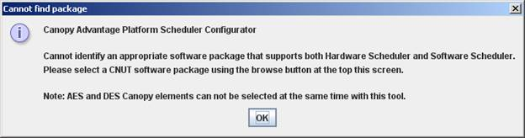

This screen should appear. Press OK to continue.

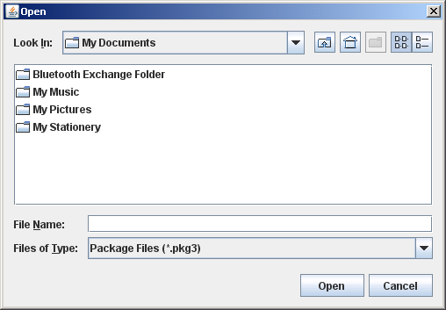

Here you must choose location of 7.3.6 software version on which the unit is running at the moment.

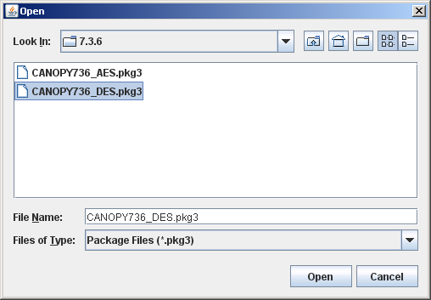

Once you got it, press open to pick it.

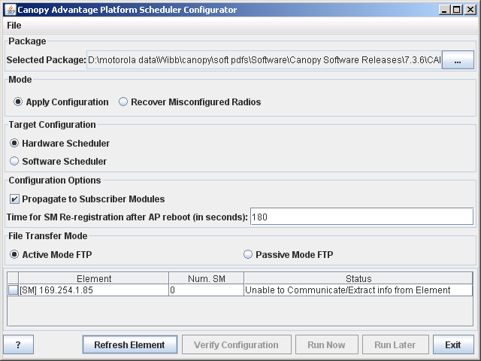

After the software has been loaded, in the bottom of the window you should be able to see the unit details.  If it does not appear just press Refresh Element button to let application do it for you.

Refresh sometimes all network and update each packet doing the same process.